to start the mongoes db

to start the mongoes db

--> npm run start

above command is use to run backend to connect with mongooes DB

backend end at 55 video

in video 55

cd (foldername)

example(cd .\backend\)

npm run both (code)

no working as harry code then add this in code by referring to a comment(in video 55)

04

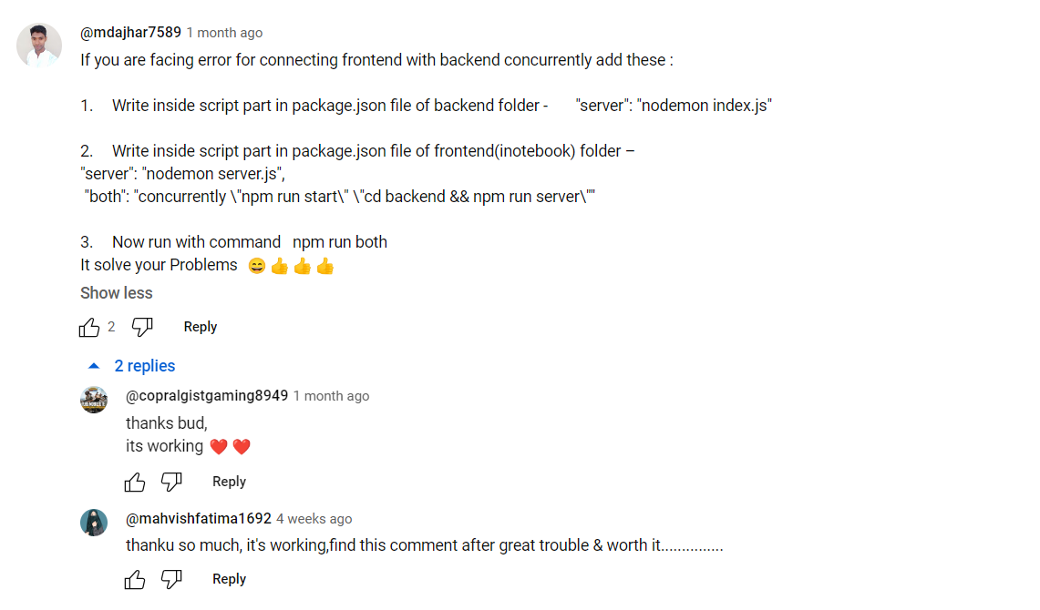

IN video 64 harry remove the highlighting home and about that is useeffect

But we have kept it as it is